I have worked on several academic and group projects that improved my teamwork, research, and presentation skills.
I also participated in debates and seminars which helped me develop strong communication confidence

- MS Word, Excel, PowerPoint
- Communication and Presentation Skills
- Teamwork and Time Management
- Problem Solving and Creativity
- Online Research and Typing Skills

- English (Fluent)
- Urdu (Native)
- German

📞 Phone: +92 300 1234567
✉️ Email: yourname@gmail.com
📍 Address: Multan, Pakistan
🌐 LinkedIn: linkedin.com/in/your name

I am a hardworking and motivated individual with a passion for learning new skills. I always try to give my best in every task and believe in teamwork and discipline. I aim to build a successful career where I can use my knowledge and grow professionally.

SKILLS
ANGUAGE
LANGUAGE
EDUCATION
CONTACTS
ABOUT ME

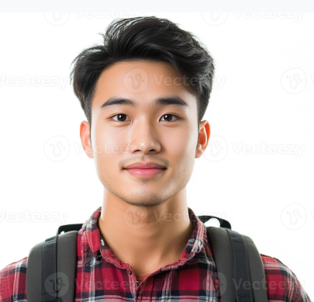
JAMAN SON
I have worked on several academic and group projects that improved my teamwork, research, and presentation skills.
I also participated in debates and seminars which helped me develop strong communication confidence

EXPERIENCE
ACTS

